TASK #9(A)

Name : Muhammad Ali

SID: 9363

Question : Design a bus network which consist of 4 routers attach 3 PC’s each with route 1 and router 4 with the help of switch . Configure EIGRP on this network. EIGRP process id should be on your std id. Also Configure Dynamic NAT on Router1. Dynamic NAT pool name should be on your name. Use the network addresses which have been assign to each student in lab session.

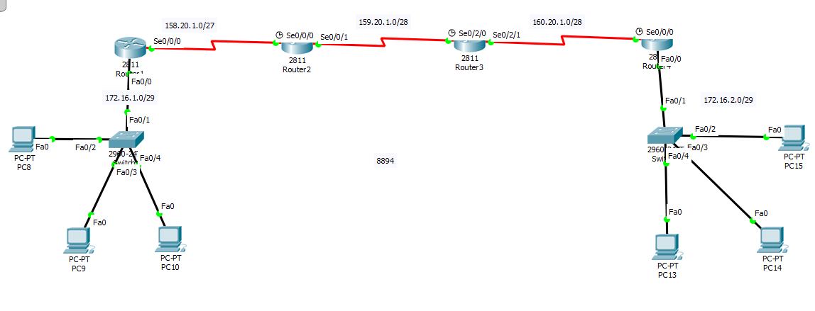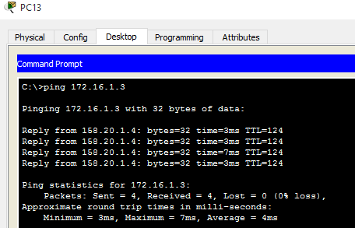

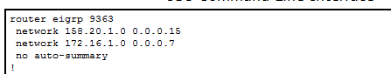

TASK #9(B)

Name : Muhammad Ali

SID: 9363

Q. Configure DHCP on given network so that all attached pcs should be able to get dynamic IPs. DHCP pool name should be on your name.

